Project on
PREDICTION OF STUDENT PERFORMANCE
Using Logistic Regression, Random Forest Classifier, Decision Tree Classifier
Submitted in partial fulfillment of the requirements for the award of the degree of
Bachelor’s of Computer Applications
To
Institute of Technology & Science Mohan Nagar ,Ghaziabad


Submitted To: Submitted To:
Mr. Prateek Gupta Aman Arora(220934106032)

ACKNOWLEDGEMENT

We want to express our heartfelt gratitude and appreciation to all the individuals who have contributed to the successful completion of our group project.
We would also like to thank our professor Mr. Prateek Gupta for his guidance and support. Their expertise and mentorship have been instrumental in shaping our project and pushing us toward excellence.
We are thankful to our principal for giving us the opportunity to work on this project.
We want to thank our fellow group members for their hard work, dedication, and cooperation throughout the project. Each team member played a crucial role, bringing unique skills and perspectives, greatly enriching our work.
We are truly grateful for the collaboration, guidance, support and resources provided. Thank you all for making this project a fulfilling and rewarding experience.
CERTIFICATE

This is to certify that the project work presented in this report entitled “STUDENT PERFORMANCE USING REGRESSION” for the award of Bachelor of Computer Applications from INSTITUTE OF TECHNOLOGY & SCIENCE, Mohan Nagar, Ghaziabad, under my supervision. The report embodies result of original work and studies carried out by students themselves and the contents of the report do not form the basis for the award of my other degree to the candidate or to anybody else.

Date: Mr. Prateek Gupta (SUPERVISOR)
I.T.S. MOHAN NAGAR GZB

INDEX

S No. | Title | Page
1 | Chapter 1  Introduction to Python | 1-2
2 | Chapter 2  Introduction to Python Libraries | 4-6
3 | Chapter 3  Introduction to Machine Learning | 7-9
4 | Chapter 4  Types of Machine Learning | 10-12
5 | Chapter 5  Python & Machine Learning Code | 13-52
6 | Chapter 6  Conclusion | 53

Chapter-1
Introduction to Python

Python is a general-purpose, high-level programming language. With a strong emphasis on indentation, its design philosophy prioritizes code readability.
Python uses garbage collection and dynamic typing. It is compatible with various programming paradigms, such as object-oriented, functional, and structured (especially procedural). Because of its extensive standard library, it is frequently referred to as a "batteries included" language.

History of Python
The programming language Python was created in the late 1980s, and its implementation was initiated in December 1989 at CWI in the Netherlands by Guido van Rossum. Van Rossum is the principal author of Python, and the Python community has named him Benevolent Dictator for Life (BDFL) in recognition of his ongoing pivotal role in determining the language's future. Python was originally conceived as a successor to ABC, capable of handling exceptions and interacting with the Amoeba operating system. On July 12, 2018, Van Rossum, however, resigned from his position as leader. The BBC TV series Monty Python's Flying Circus inspired the moniker Python.

Why learn Python?

- Easy to Learn and Use: Python's simple, clear syntax makes it accessible for beginners, unlike more complex languages like C, C++, or Java.
- Interpreted Language: Python is an interpreted language, eliminating the need for compilation and enabling faster development and testing.
- Object-Oriented: Python supports object-oriented programming features like inheritance, encapsulation, polymorphism, and abstraction, facilitating the creation of reusable and modular code.
- Extensive Libraries: Python boasts a vast ecosystem of libraries and frameworks, such as NumPy, Pandas, and Matplotlib, that simplify tasks like data manipulation and visualization.

Where is Python used?

- Data Science: - Python plays a crucial role in data science thanks to its ease of use and powerful tools like NumPy, Pandas, and Matplotlib, which facilitate data analysis and visualization.

- Machine Learning: - Python is extensively used in machine learning for its simplicity, user-friendliness, and access to robust machine learning libraries.

- Data Analysis: - Python is popular for data analysis because its libraries, such as Pandas and NumPy, streamline data manipulation and cleaning, while its clear syntax simplifies complex operations, making it ideal for gaining insights from large datasets.

Chapter 2
Libraries of Python

- Python libraries are pre-written code packages that extend Python's capabilities. They offer tools for various tasks:

- Data Manipulation: Pandas, NumPy
- Data Visualization: Matplotlib, Seaborn, Plotpy
- Machine Learning: Scikit-learn, TensorFlow, PyTorch
- Web Development: Django, Flask
- Database Interaction: SQLAlchemy, PyMongo
- Automation: Selenium, BeautifulSoup
These libraries help streamline development by providing reusable components and simplifying complex processes.

- NumPy

Introduction

NumPy, which stands for Numerical Python, is a fundamental library for numerical computing in Python. It provides support for large, multi-dimensional arrays and matrices, along with a range of mathematical functions to efficiently manipulate these arrays.

Features of NumPy:

- Efficient Array Object: NumPy provides a highly efficient multi-dimensional array object, numpy.ndarray, designed to handle and manage large datasets quickly.

- Numerical Computing Tool: It offers a wide range of tools and functions for performing numerical computations on arrays.

- Array Manipulation: NumPy includes routines for various array manipulations, including reshaping (reshape()), stacking(stack(), hstack(), vstack()), splitting (split()), as well as indexing, slicing, and sorting.

Advantages of NumPy

- Performance:

- Speed: NumPy arrays are faster than Python lists due to their underlying optimized C code.

- Vectorization: Supports element-wise operations directly, avoiding the need for explicit loops.
2. Memory Efficiency:
- Contiguous Allocation: Arrays are stored in contiguous memory locations, improving cache efficiency.

- Homogeneous Types: Ensures consistent memory usage by storing elements of the same type.

- Pandas

Pandas is a powerful and versatile Python library for data manipulation and analysis. It features high-level data structures, such as DataFrame and Series, that simplify working with structured data.

Key Features of Pandas:

- DataFrame: A two-dimensional, labeled data structure resembling a spreadsheet or SQL table, ideal for tabular data.

- Series: A one-dimensional, labeled array capable of holding any data type, functioning like a column in a DataFrame or a named array.

- File I/O: Supports reading from and writing to various file formats, incuding CSV, Excel, SQL databases, and JSON.

- Indexing: Provides advanced indexing with loc for label-based selection and iloc for integer-based selection, facilitating easy data access.

Advantages of Pandas:

- Data Manipulation and Analysis:

- DataFrames: Efficiently manage tabular data with labeled rows and columns.

- Series: Simplify handling of one-dimensional labeled arrays.

- Data Cleaning:

- Handling Missing Data: Tools for detecting, filling, and removing missing values.

- Data Transformation: Easy methods for merging, reshaping, and transforming datasets.

- Data Selection:

- Indexing and Slicing: Powerful and flexible data selection capabilities.

- Label-based and Position-based Indexing: Access data using labels or positions.

3. Matplotlib

Matplotlib is a powerful Python library for creating static, animated, and interactive visualizations. It is widely used for data visualization and provides a flexible framework for generating plots and figures in various formats.

Key Features of Matplotlib:

- Variety of Plots: Supports diverse graph types, including line plots, scatter plots, bar plots, histograms, pie charts, and 3D plots.

- Integration with Pandas and NumPy: Allows direct plotting from DataFrame and Series objects.

- Compatibility with Seaborn: Works well with Seaborn, enhancing functionality with high-level statistical plots like violin, box, and regression plots.

Advantages of Matplotlib:

- Versatility:

- Wide Range of Plots: Supports various plot types like line, bar, scatter, histogram, and pie.

- Customizable: Allows detailed adjustments to create tailored visualizations.

- Integration:

- Seamless with NumPy and Pandas: Easily plots data from NumPy arrays and Pandas DataFrames.

- Compatible with Other Libraries: Works well with libraries like SciPy and scikit-learn.

- Publication Quality:

- High-Quality Output: Generates figures suitable for publication.

- Multiple Formats: Exports plots in formats such as PNG, PDF, SVG, and EPS.

4. Seaborn

Seaborn is a Python data visualization package built on Matplotlib. It provides a high-level interface for constructing visually appealing and useful statistical graphs.

Key Features of Seaborn:

- Intuitive API: Simplifies the creation of complex statistical graphs with fewer lines of code compared to Matplotlib.

- Built-in Color Palettes: Offers color schemes for qualitative, sequential, and divergent data to enhance visualizations.

- Integration with Pandas: Easily visualizes data directly from Pandas DataFrames.

Advantages of Seaborn:

- High-Level Interface:

- Ease of Use: Creates complex visualizations with minimal code.

- Intuitive API: Offers a user-friendly syntax for creating informative and appealing statistical graphics.

- Statistical Visualization

- Built-in Support: Integrates seamlessly with Pandas DataFrames for statistical aggregation and visualization.

- Advanced Plotting Functions: Provides specialized plots such as categorical, distribution, and regression plots.

Chapter 3
Machine Learning

Introduction
Machine learning (ML) is a branch of artificial intelligence (AI) focused on creating algorithms and statistical models that allow computers to perform tasks without direct programming. Instead, these systems learn from data to identify patterns and make decisions. ML is revolutionizing industries by automating complex tasks, deriving insights from large datasets, and fostering innovative opportunities.

How Machine Learning Works:
1. Decision Process: Machine learning algorithms make predictions or classifications based on input data, which can be either labeled or unlabeled. The algorithm estimates patterns or outcomes from this data.
2. Error Function: An error function assesses the accuracy of the model’s predictions by comparing them to known examples, providing a measure of how well the model is performing.
3. Model Optimization: The model’s parameters, or weights, are adjusted to minimize the discrepancy between its predictions and the actual data. This iterative process of evaluating and optimizing continues until the model achieves a satisfactory level of accuracy.

Definition and Scope of Machine Learning:
1. Definition: Machine learning (ML) is a subset of artificial intelligence (AI) that develops algorithms and statistical models enabling computers to learn and make decisions from data without explicit programming.
2. Data Collection: Gathering large and diverse datasets to provide the foundation for learning.
3. Data Preprocessing: Cleaning and formatting data to ensure it is suitable for analysis and model training.
4. Model Selection: Choosing appropriate algorithms or models based on the specific task or problem.
5. Training: Feeding data into the model to enable it to learn patterns and make predictions.
6. Evaluation: Assessing the model’s performance using metrics and validation techniques to ensure accuracy and effectiveness.
7. Deployment: Implementing the trained model into real-world applications for practical use.
8. Maintenance: Continuously updating and refining the model as new data becomes available to improve its performance.

Advantages of Machine Learning:
1. Automation: Automates repetitive tasks and decision-making processes.
2. Data Insights: Analyzes large datasets to uncover hidden patterns and insights.
3. Adaptability: Models can improve and adapt over time with new data.
4. Efficiency: Enhances efficiency and accuracy in various applications like prediction and classification.

Disadvantages of Machine Learning:
1. Data Dependency: Requires large amounts of high-quality data for training.
2. Complexity: Can be complex to implement and understand, requiring specialized knowledge.
3. Overfitting: Models might perform well on training data but fail to generalize to new, unseen data.
4. Bias: Models can inherit and amplify biases present in the training data.

Chapter -4
Types of Machine Learning

Types of Machine Learning:

1. Supervised Learning:
- Description: Involves training a model on a labeled dataset, where the input data is paired with corresponding output labels. The goal is for the model to learn the mapping from inputs to outputs and make predictions on new, unseen data.

Advantages:

- Predictive Accuracy: Generally provides high accuracy if trained with sufficient and high-quality labeled data.

- Defined Objectives: Clear and well-defined objectives make it easier to evaluate and measure model performance.

- Wide Applicability -: Effective for a variety of tasks such as classification, regression, and forecasting.

Disadvantages:
- Data Dependency: Requires a large amount of labeled data, which can be costly and time-consuming to obtain.

- Overfitting Risk: Models may overfit to training data if not properly validated, leading to poor generalization on new data.
- Bias: Models can inherit and perpetuate biases present in the training data.

2. Unsupervised Learning:
- Description: Involves training a model on data without labeled responses. The goal is to identify hidden patterns or structures in the data, such as grouping similar data points together.

Advantages:
- No Labeled Data Required: Useful when labeled data is scarce or expensive, as it works with unlabeled data.

- Pattern Discovery: Can uncover hidden patterns or relationships within the data that are not immediately apparent.

- Data Exploration: Helpful for exploring data and understanding underlying distributions.
Disadvantages:

- No Clear Objective: Lack of predefined labels makes it challenging to evaluate and interpret model performance.

- Interpretation Difficulty: Results, such as clusters or associations, may be harder to interpret and validate.

- Scalability Issues: May face challenges with scalability and handling very large datasets efficiently.

3. Semi-Supervised Learning:
- Description: Combines a small amount of labeled data with a large amount of unlabeled data to improve model performance. It leverages both types of data to better learn patterns and make predictions.
Advantages:
- Reduced Labeling Costs: Reduces the need for extensive labeled data by using a combination of labeled and unlabeled data.

- Improved Performance: Can enhance model performance compared to using only a small labeled dataset.

- Better Utilization of Data: Effectively utilizes unlabeled data to supplement the learning process.

Disadvantages:
- Complexity: More complex to implement and tune compared to purely supervised or unsupervised learning methods.

- Quality of Unlabeled Data: The model’s effectiveness depends on the quality and representativeness of the unlabeled data.

- Overfitting Risk: If not managed properly, reliance on unlabeled data can lead to overfitting or inaccurate results.

4. Reinforcement Learning:
- Description: Involves training a model through interaction with an environment to learn optimal actions that maximize cumulative reward. The model learns by receiving feedback in the form of rewards or penalties.
Advantages:
- Learning Through Interaction: Effective for complex tasks where the model learns by interacting with the environment and making decisions.

- Adaptability: Can adapt to changing environments and improve performance over time through continuous learning.

- Decision-Making: Well-suited for problems requiring sequential decision-making, such as robotics and game playing.

Disadvantages:
- High Computational Cost: Requires significant computational resources and time for training due to trial-and-error learning.

- Complex Implementation: More complex to implement and fine-tune compared to other types of machine learning.

- Delayed Rewards: Learning can be slow and challenging when rewards are sparse or delayed, making it difficult to correlate actions with outcomes.

Chapter-5
Python and Machine learning Code

- Importing key libraries for data manipulation, visualization, and machine learning.
- Prepares the environment for subsequent data analysis and modeling tasks.
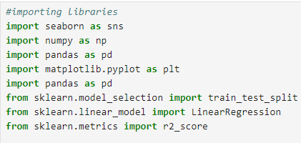
- Converts the student_performance_raw dataset from a CSV file into a Pandas DataFrame named df for further analysis.
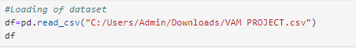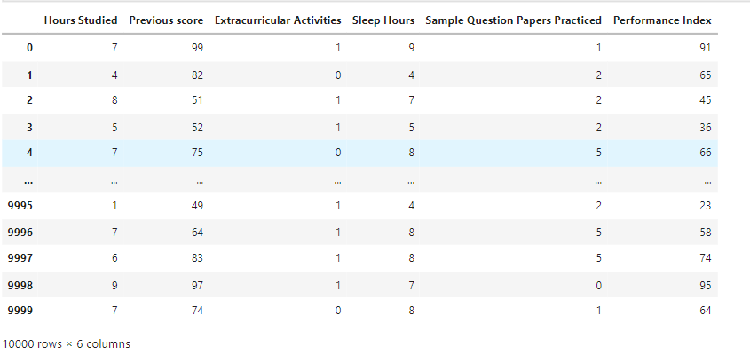

- It will print the dimensions (rows, columns) of the dataset.
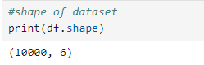
- This code will display every information of the dataset, including data types, non-null counts, and memory usage.
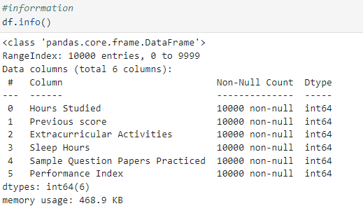

- It will count the number of non-null values in each column of the dataset

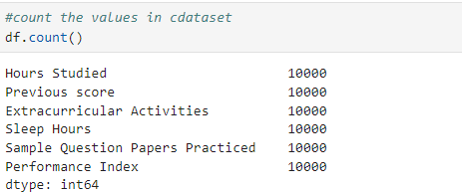
- This code generates summary statistics (e.g., mean, median, min, max) for numerical columns in the dataset.
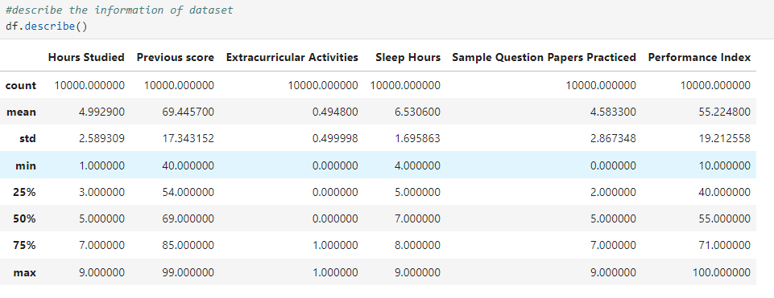
- This code displays the first 5 rows of the dataset.
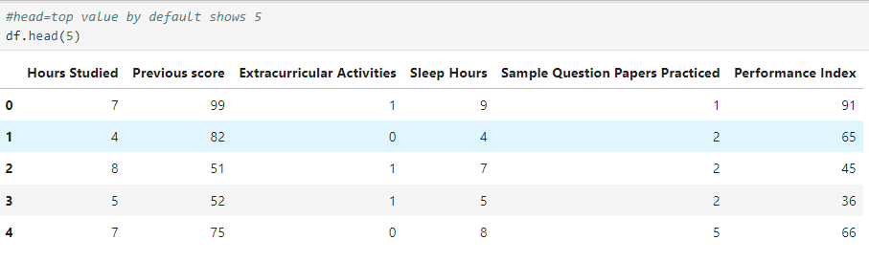
- This code displays the last 5 rows of the dataset.
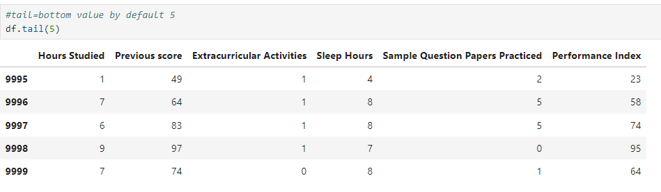

- It will calculate and prints the mean of selected columns from the dataset.

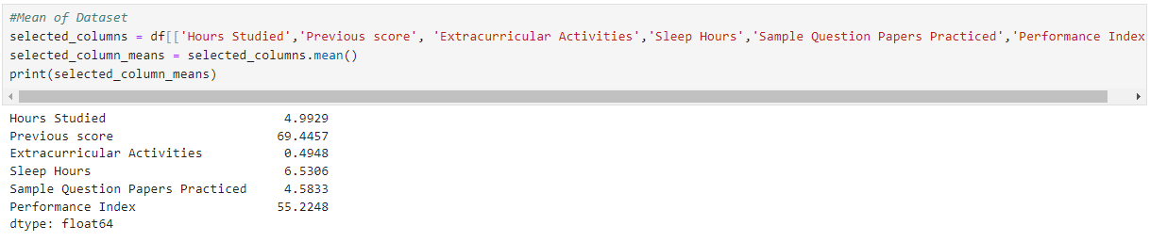

- It will calculate and prints the median of selected columns from the dataset.
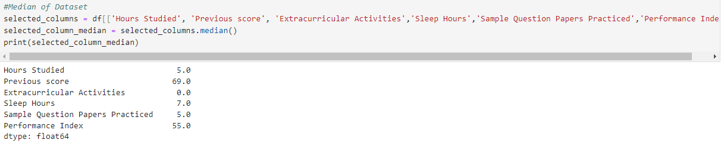

- It will calculate and prints the mode (most frequent value) of selected columns from the dataset.
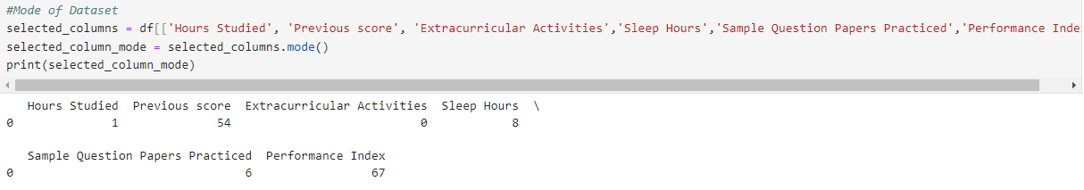
- This code prints the minimum value for each selected column in the dataset. It displays the minimum values for 'Hours Studied', 'Previous Scores', 'Extracurricular Activities', 'Sleep Hours', 'Sample Question Papers Practiced', and 'Performance Index'.
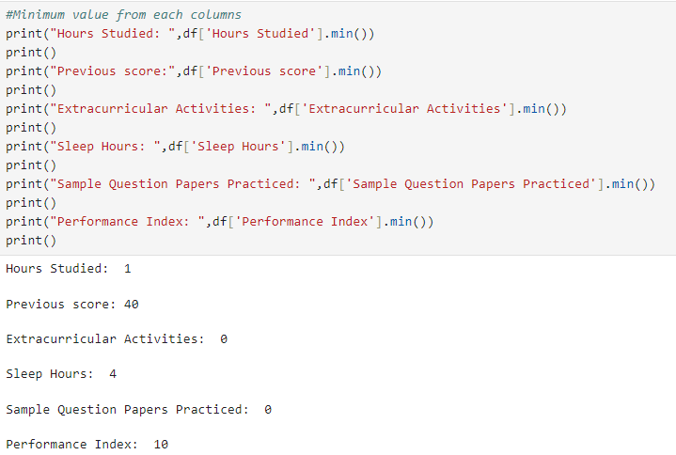

- This code prints the maximum value for each selected column in the dataset. It displays the maximum values for 'Hours Studied', 'Previous Scores', 'Extracurricular Activities', 'Sleep Hours', 'Sample Question Papers Practiced', and 'Performance Index'.
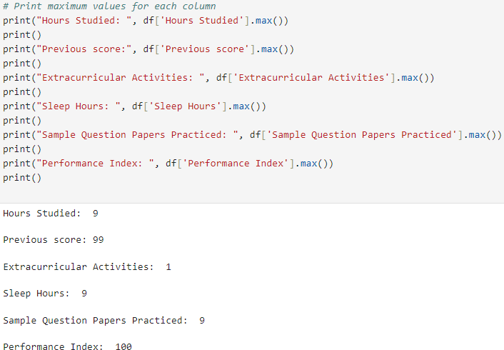

- It will check and return the count of null (missing) values in each column of the dataset.
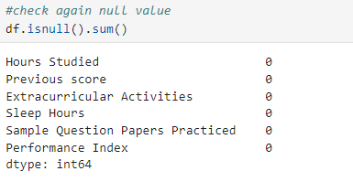

- This code counts and returns the number of duplicate rows in the dataset.
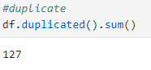

- This code drops the column 'Extracurricular Activities' from the dataset. The inplace=True argument modifies the dataset directly
without needing to assign it to a new variable.
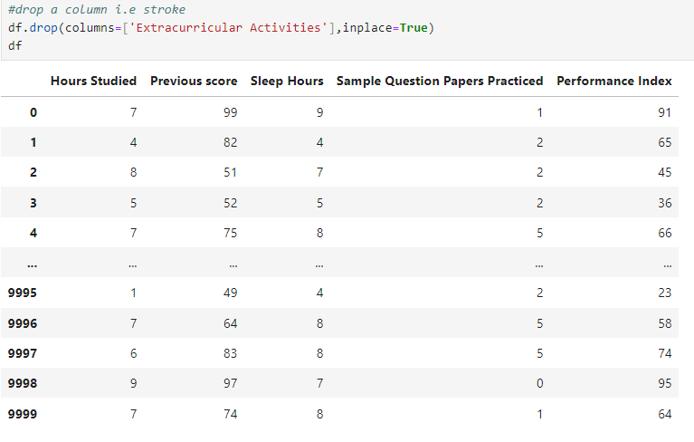

- This code creates a boxplot to visualize the distribution and outliers of the 'Hours Studied' column in the dataset.
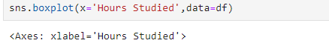
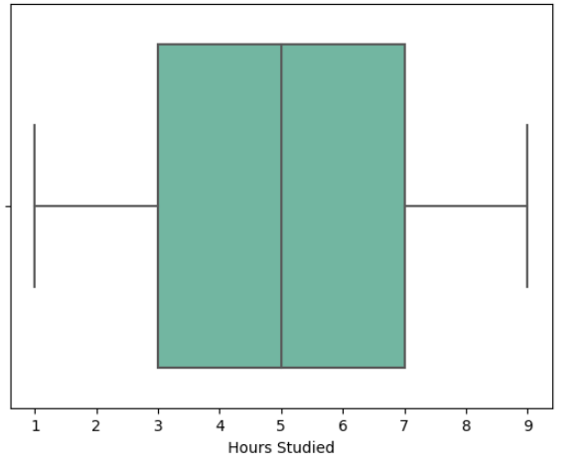

- This code creates a boxplot to visualize the distribution and outliers of the 'Sleep Hours' column in the dataset.
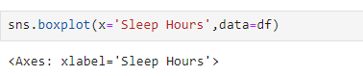
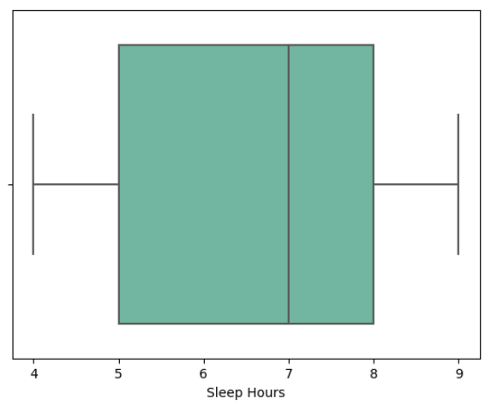

- This code creates a boxplot to visualize the distribution and outliers of the 'Sample Question Papers Practiced' column in the dataset.
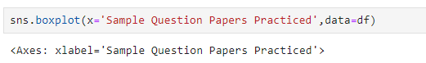
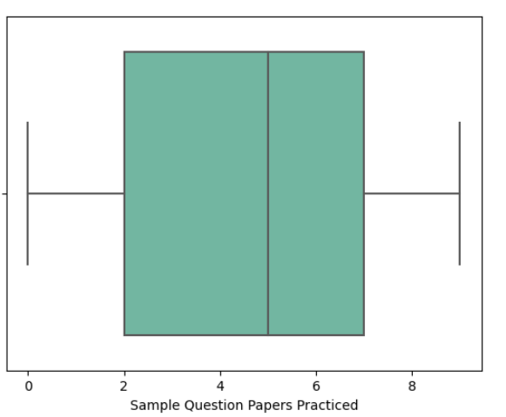

- This code creates a boxplot to visualize the distribution and outliers of the 'Performance Index' column in the dataset.
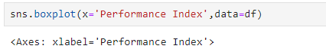
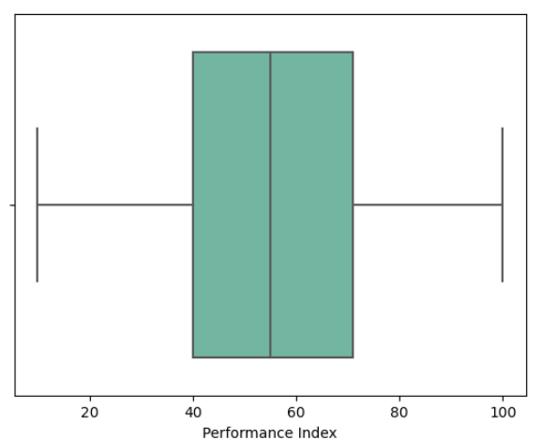

- This code calculates the Interquartile Range (IQR) for the 'Hours Studied' column and identifies outliers using a threshold of 2.5 times the IQR. It filters and displays the rows where 'Hours Studied' values are considered outliers.
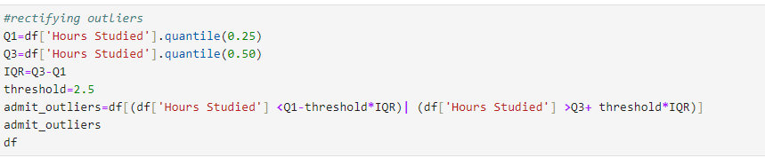
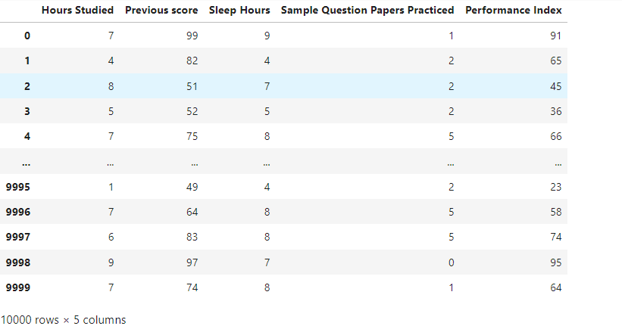

- This code resets the index of the DataFrame and adds a new sequential index, while the old index is moved to a column.
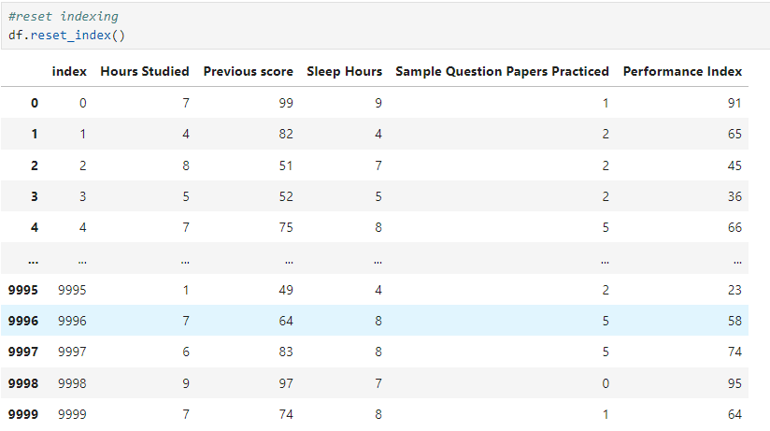

This code creates a pairplot to visualize pairwise relationships between all numerical columns in the dataset.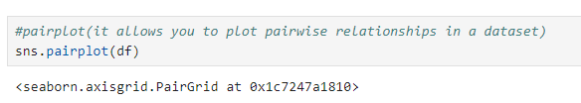
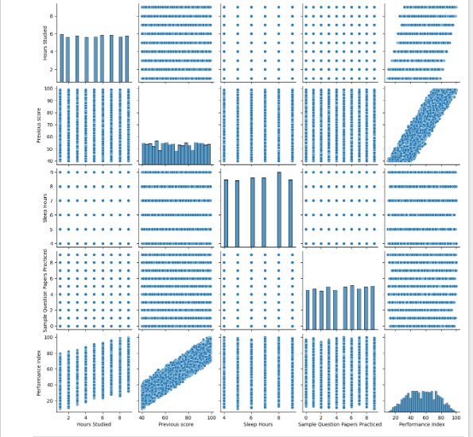

- This code creates a scatterplot to visualize the relationship between 'Hours Studied' and 'Performance Index' in the dataset.

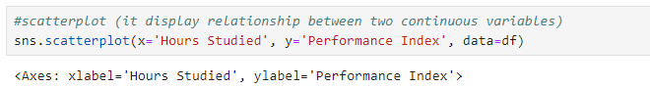
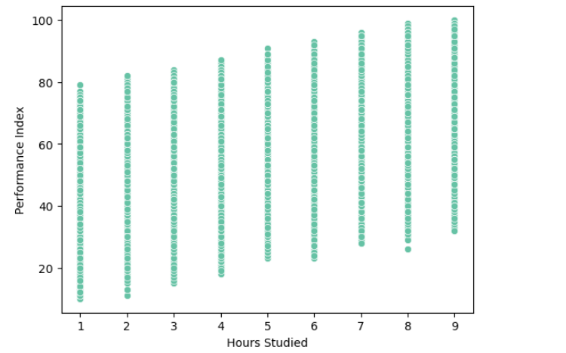

- This code creates a barplot to visualize the relationship between 'Previous Scores' and 'Performance Index' using a 'coolwarm' color palette.
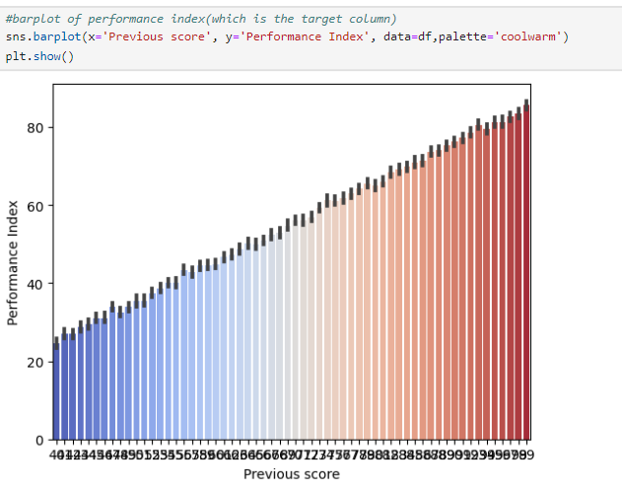

- This code creates a histogram to visualize the distribution of 'Hours Studied' and 'Performance Index', with color differentiation basedon the 'PerformanceIndex’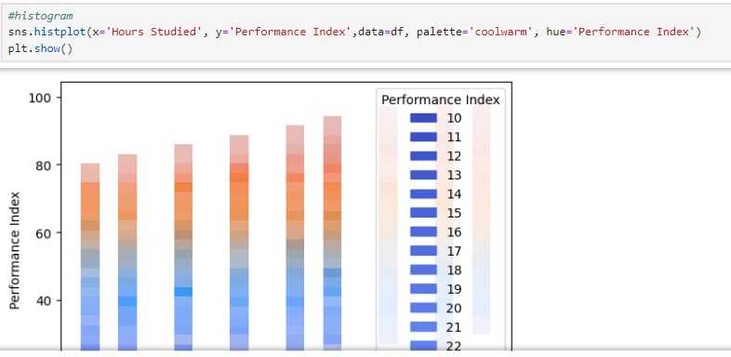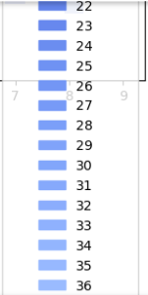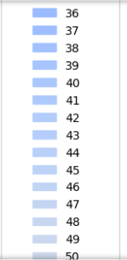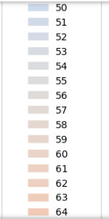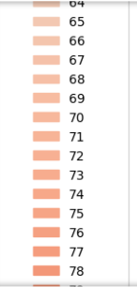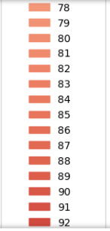
- This code creates a line plot to visualize the relationship between 'Sleep Hours' and 'Performance Index'

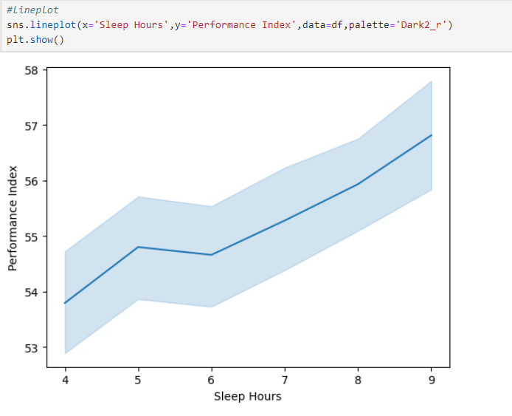

- This code creates a barplot to visualize the relationship between 'Sample Question Papers Practiced' and 'Performance Index' using the 'coolwarm' color palette.
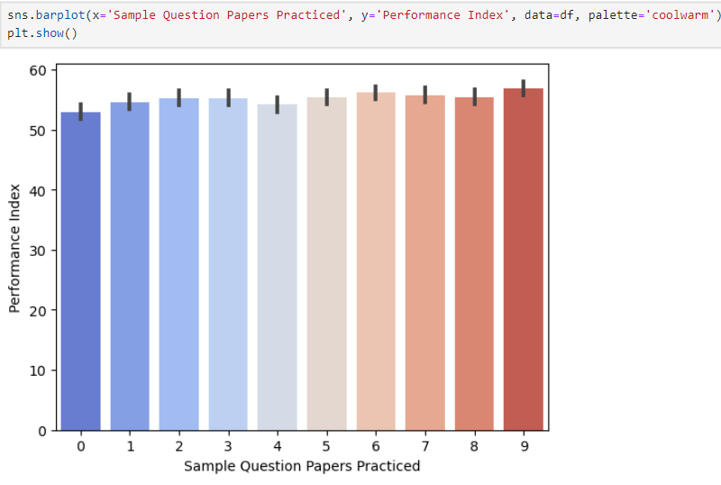

- This code creates a countplot to visualize the frequency distribution of the 'Previous Scores' column using the 'Greens' color palette.
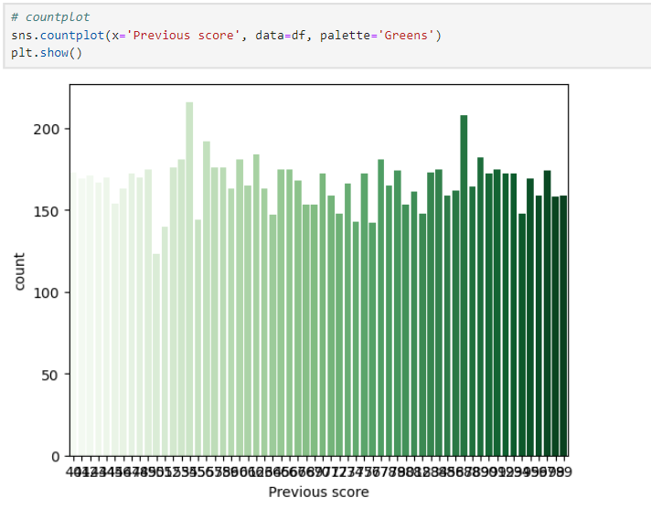

- This code groups the dataset by 'Hours Studied' and calculates the mean for various columns, then visualizes the relationship between 'Hours Studied' and 'Performance Index' using a scatterplot with a regression line. It also prints the summary statistics of 'Performance Index' by 'Hours Studied'.
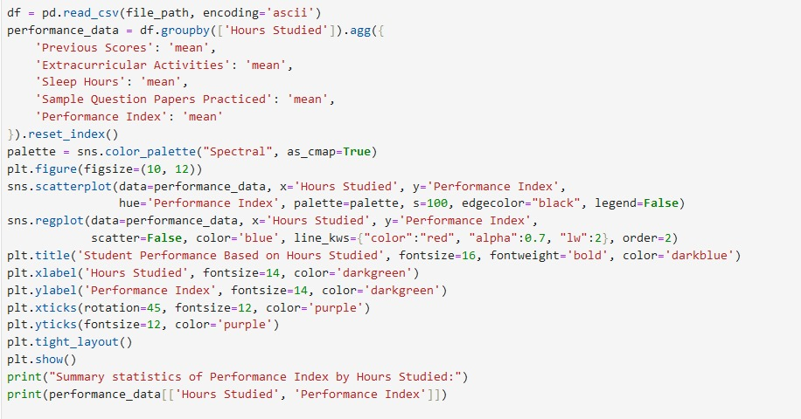

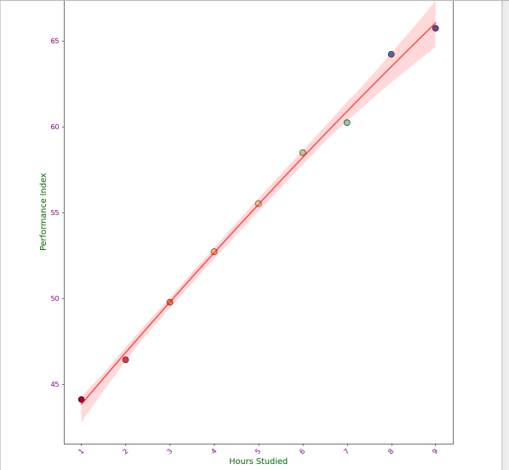
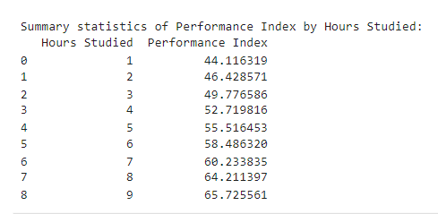

- This code groups the dataset by 'Hours Studied' and calculates the mean for various columns, then creates a set of regression plots to visualize the relationships between 'Hours Studied' and other factors. It also prints the summary statistics for each factor by 'Hours Studied'.
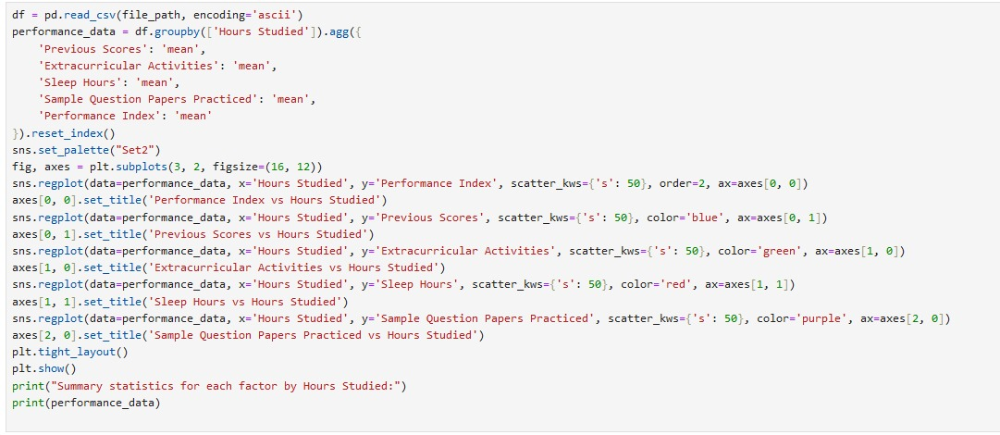

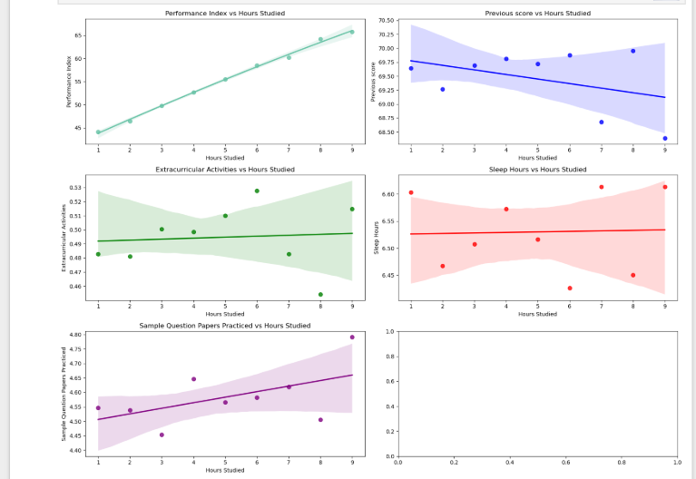

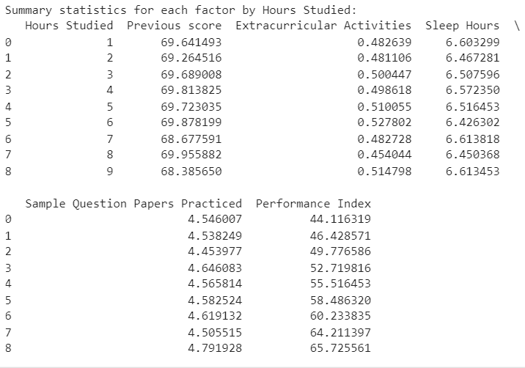

- This code groups the dataset by 'Hours Studied', melts the data for selected factors, and visualizes their trends with a lineplot, while printing the summary statistics of 'Performance Index' by 'Hours Studied'.
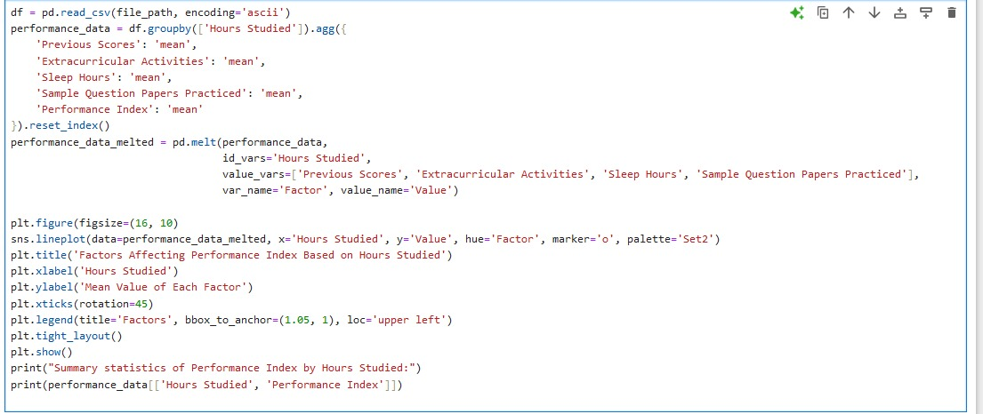

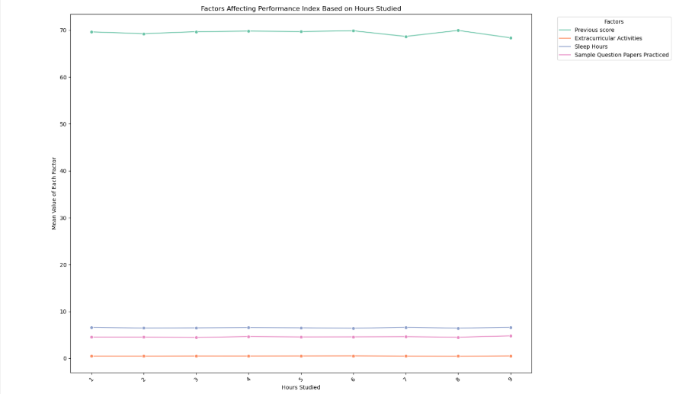

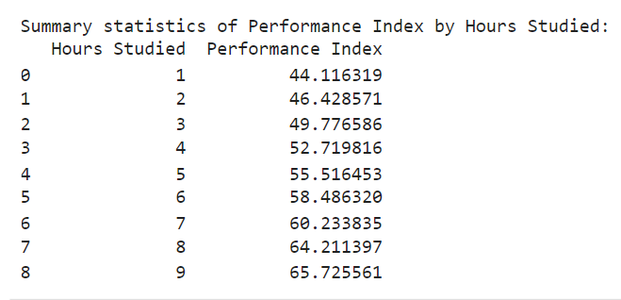

- This code selects relevant factors (excluding 'Previous Scores'), calculates the sum of each factor, and visualizes their distribution with a pie chart.
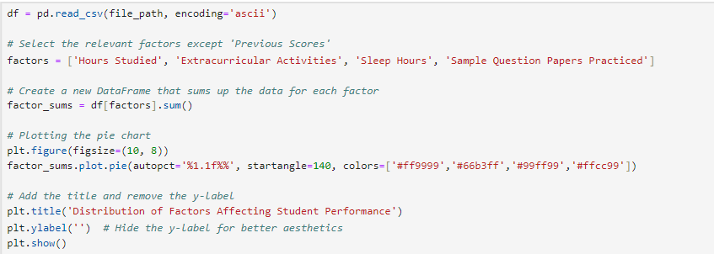

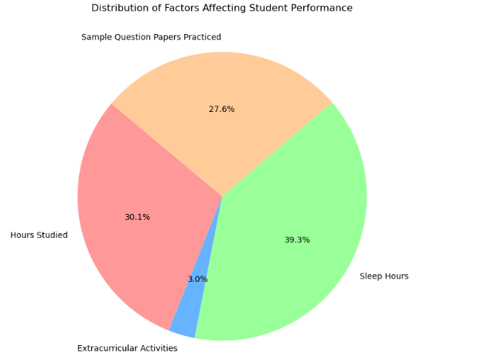

- Test and Train Splitting

- x is defined as the subset of the dataset containing the first five columns (features) for model input.
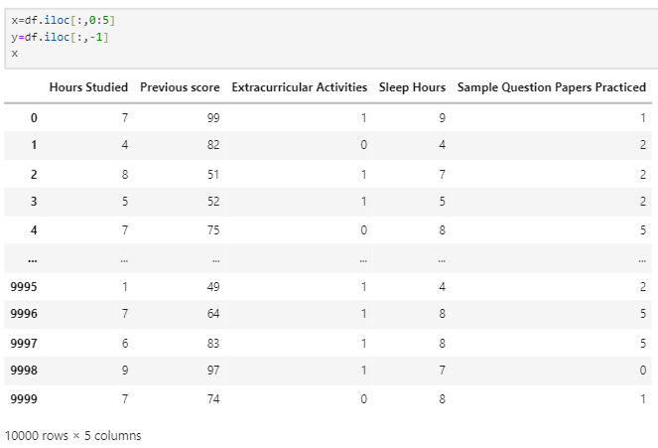

- This code loads the dataset, defines features and target variable, splits the data into training and testing sets, and prints the shapes of the resulting datasets.

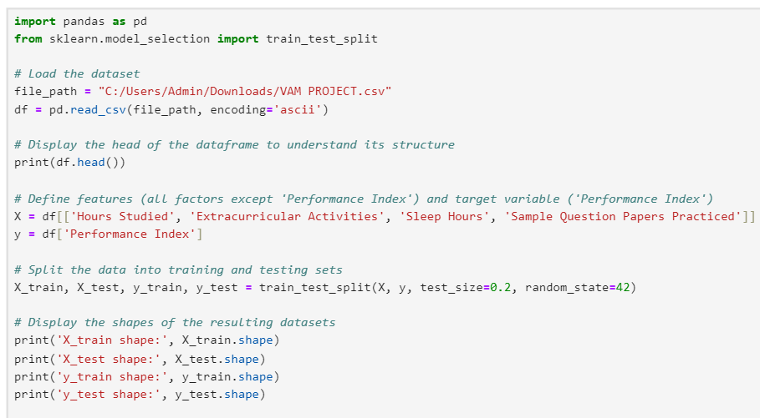
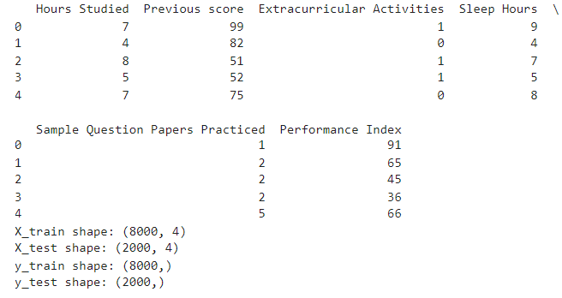

- x_train is the subset of the dataset containing the training features (75% of the data) after splitting.
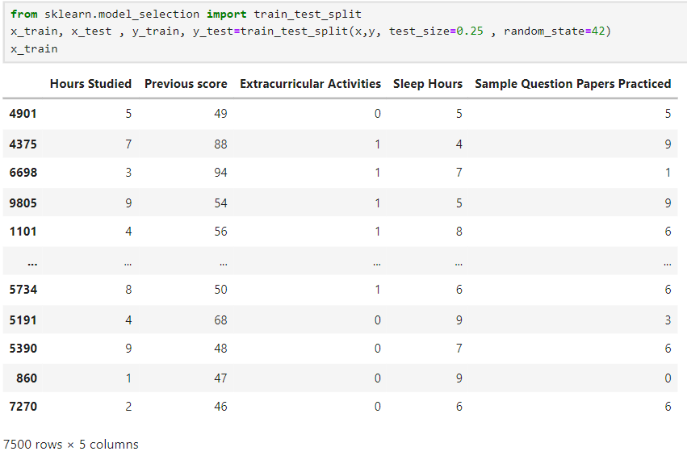

- This code displays the first few rows of the training features (x_train) and the corresponding target values (y_train) from the dataset.
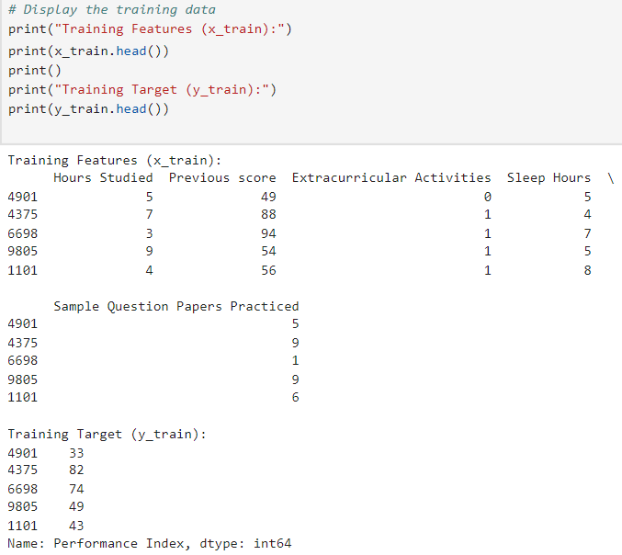
- This code displays the first few rows of the dataset to give an overview of its structure and content.
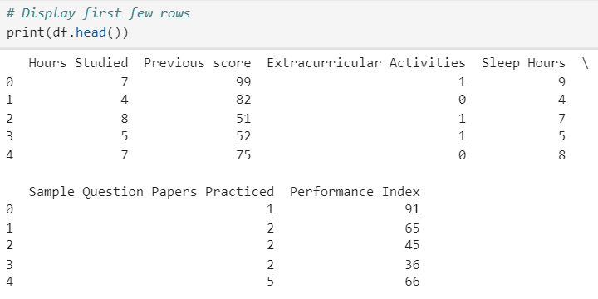

- This code splits the dataset into training and testing sets, with 80% of the data used for training and 20% for testing, ensuring reproducibility with a fixed random seed (random_state=42).
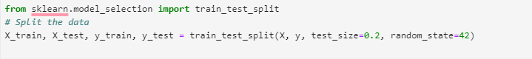

- This code splits the dataset into training and testing sets, with 80% of the data used for training and 20% for testing, ensuring reproducibility with a fixed random seed (random_state=42).
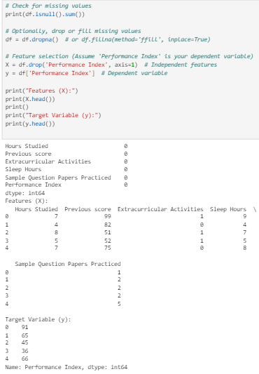

- This code creates a correlation matrix for selected factors in the dataset and visualizes it with a heatmap, showing the relationships between factors like 'Hours Studied', 'Extracurricular Activities', and 'Performance Index'.
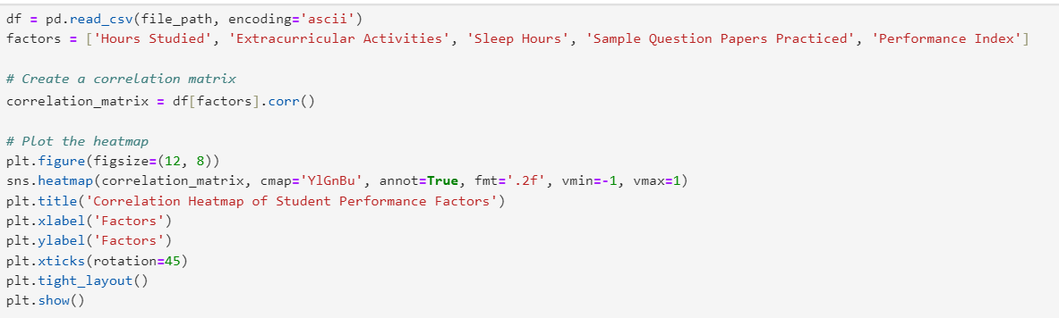
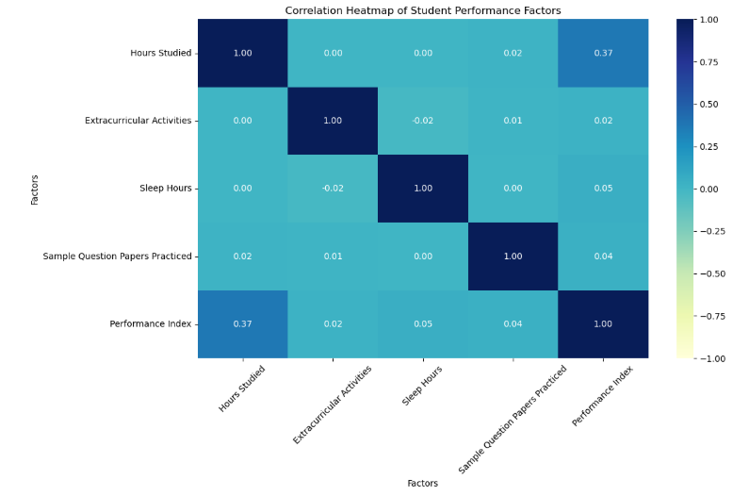

- This code loads the dataset, displays the first few rows, defines independent features (X) for predictors like 'Hours Studied' and 'Sleep Hours', and the dependent variable (Y), which is the
'Performance Index'. It then prints the first few rows of both X and Y.
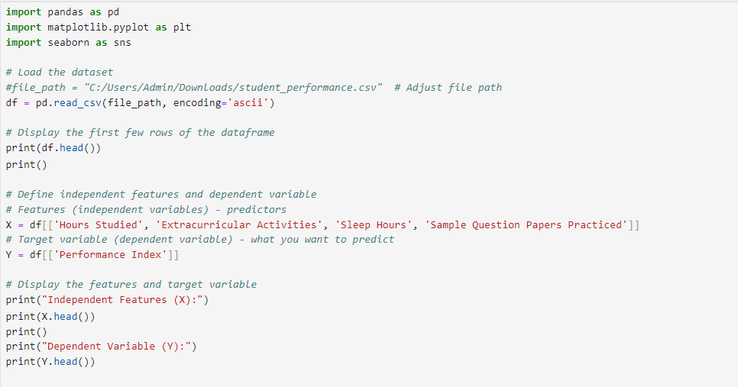
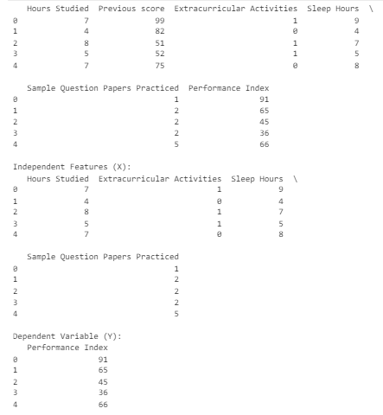

- This code loads the dataset, creates a regression plot to visualize the relationship between 'Hours Studied' and 'Performance Index', and displays the plot with a red regression line.
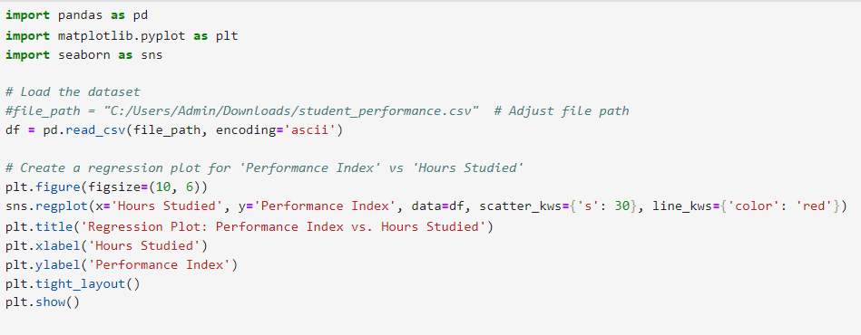
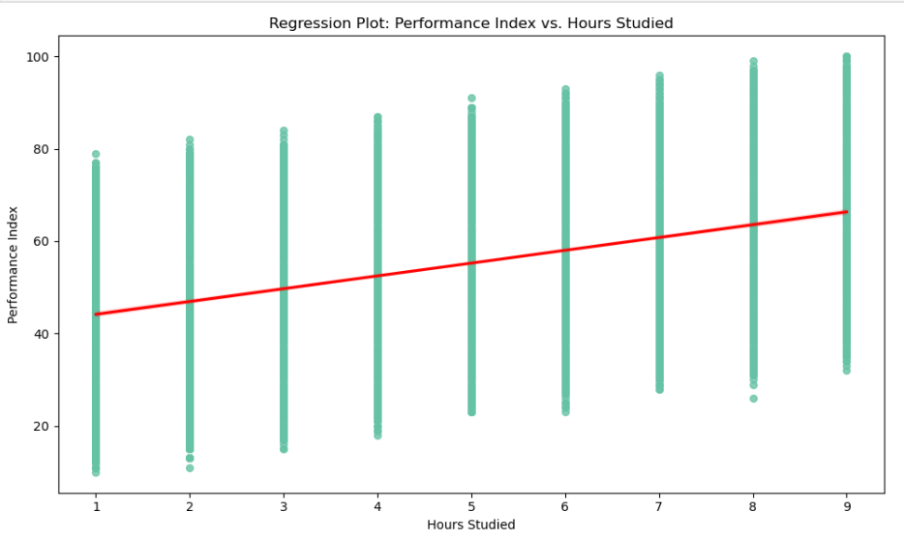

- This code initializes a linear regression model and trains it using the training data (X_train and y_train).
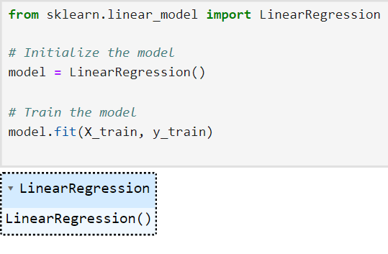

- This code uses the trained model to make predictions on the test set, calculates the Mean Squared Error (MSE) and R² score to evaluate the model's performance, and then prints these metrics.
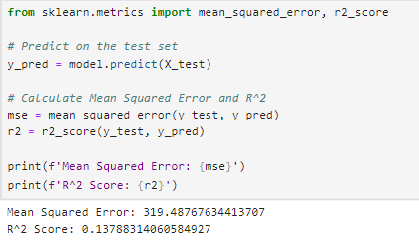
- This code creates a scatter plot to visualize the relationship between the actual values (y_test) and the predicted values (y_pred), helping to assess the model's prediction accuracy.
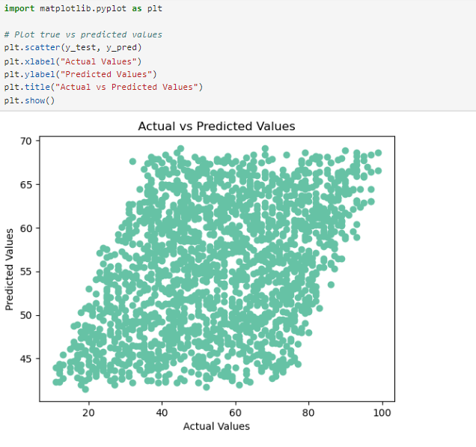

- This code saves the trained linear regression model to a file (regression_model.pkl) using joblib and then loads the model back from the file for future use.
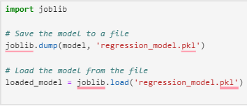

- This code trains a Decision Tree classifier on the dataset, evaluates its performance on the test set by calculating accuracy and generating a classification report. The accuracy and report are then printed.

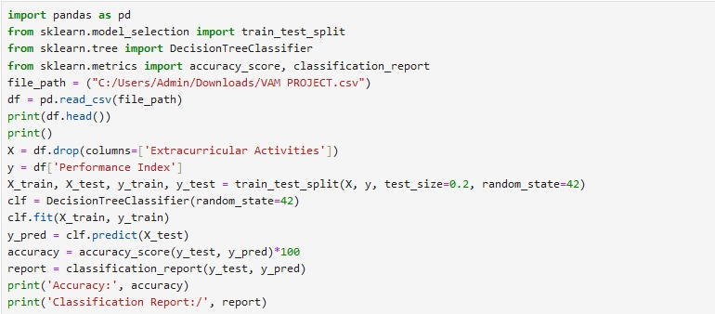

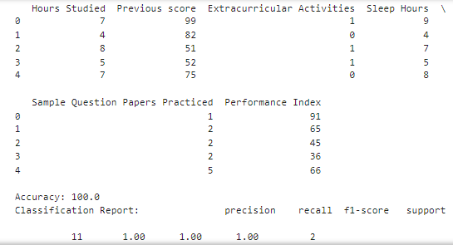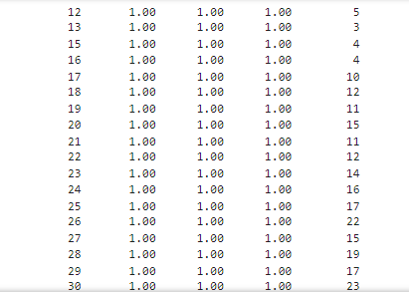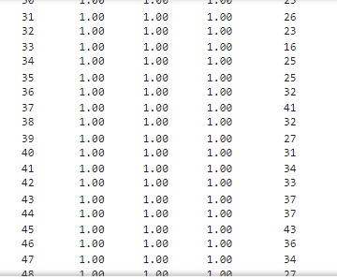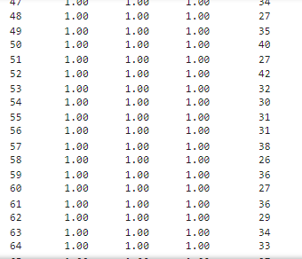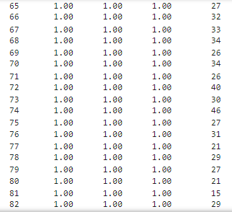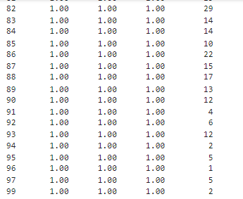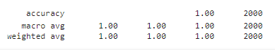

- This code trains a Decision Tree Classifier using the dataset, splits it into training and testing sets, predicts test set values, and evaluates the model's performance by calculating accuracy and displaying a classification report.
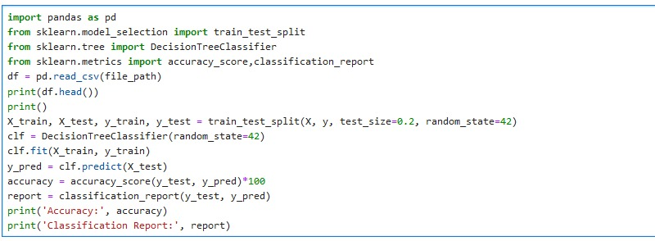
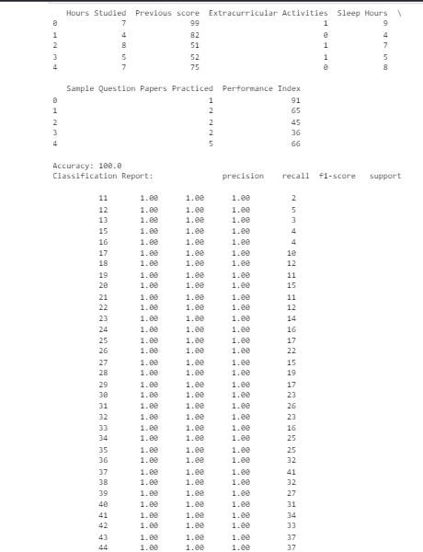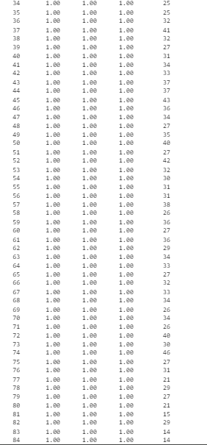
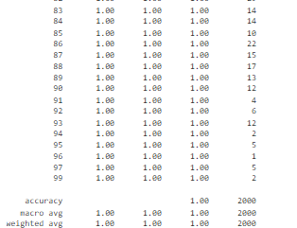

- This code trains a *Linear Regression* model to predict a target variable and evaluates its performance using the R² score. Additionally, it trains a *Random Forest Regressor* on the same dataset, evaluates its performance using Mean Squared Error (MSE), and prints the results.

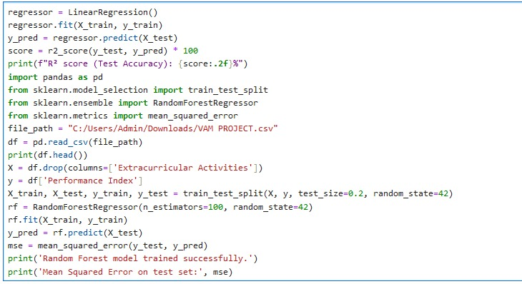

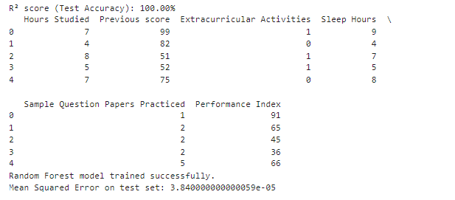

- X is the DataFrame containing the independent features (predictor variables) used for training the models after dropping the column 'Extracurricular Activities'.
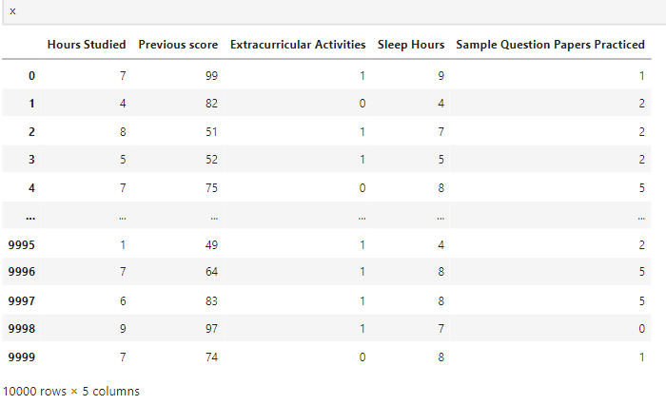

- y is the Series containing the dependent variable (target) for model training, specifically the 'Performance Index' column from the dataset.
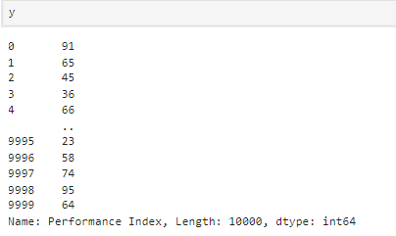

- The code trains a *Linear Regression model* with X_train and y_train, predicts y_pred1 on X_test, and calculates the *R² score* for model accuracy using r2_score.
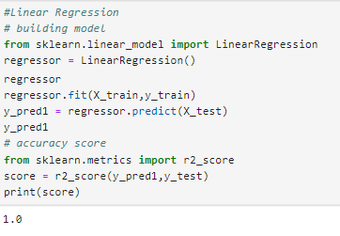
- The code trains a *Linear Regression model* on the training set (X_train, y_train), evaluates its accuracy using *R² score* on the test set (X_test, y_test), and predicts outcomes for specific inputs (Line1, Line2, Line3).
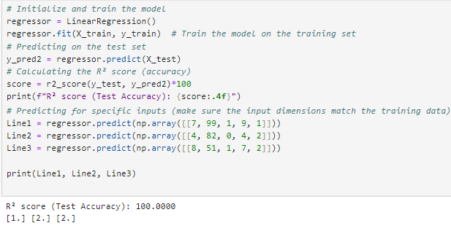

- The code initializes a *Random Forest Regressor*, trains it on X_train and y_train, evaluates it using *R² score* on predictions (y_pred3) from X_test, and predicts outcomes (Ran1, Ran2, Ran3) for specific input arrays.
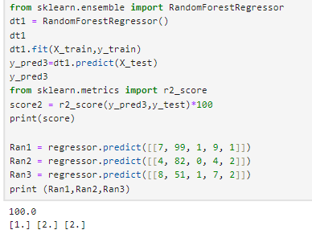

- The code initializes a *Decision Tree Regressor*, trains it with X_train and y_train, then evaluates the model's performance using *R² score* on the predictions (y_pred3) from X_test. It also makes predictions (Dec1, Dec2, Dec3) for specific inputs using the *Linear Regression model* (stored in regressor).
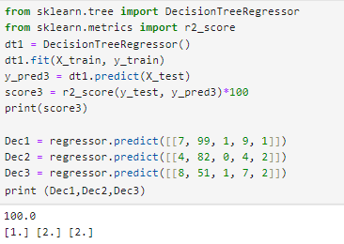

- The code creates a DataFrame, comparison_df, to compare the results of three different algorithms (Linear Regressor, Decision Tree, and Random Forest). It includes columns for the algorithm names, their accuracy scores (score, score2, score3), and their predictions for three specific input scenarios (Prediction-1, Prediction-2, and Prediction-3). This DataFrame is then displayed using comparison_df.head().

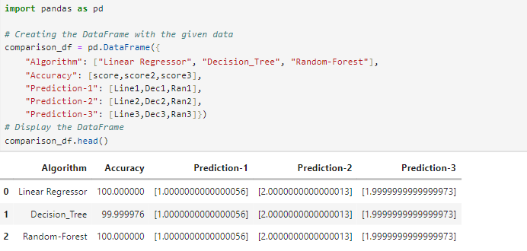

Conclusion

In this student performance dataset analysis, we explored various machine learning models to predict student performance based on factors such as hours studied, extracurricular activities, sleep hours, and sample question papers practiced. Among the models evaluated, Linear Regression, Decision Tree, and Random Forest were used, with Random Forest showing the highest accuracy and the best performance. The predictions made by the models demonstrated varying degrees of accuracy, providing insights into the relationship between study habits and academic outcomes. Overall, this analysis showcases the potential of machine learning techniques to forecast academic performance and guide improvements in student success.

THANK
YOU!

